Go to the Project/Experience Manager screen and click on the little graph.
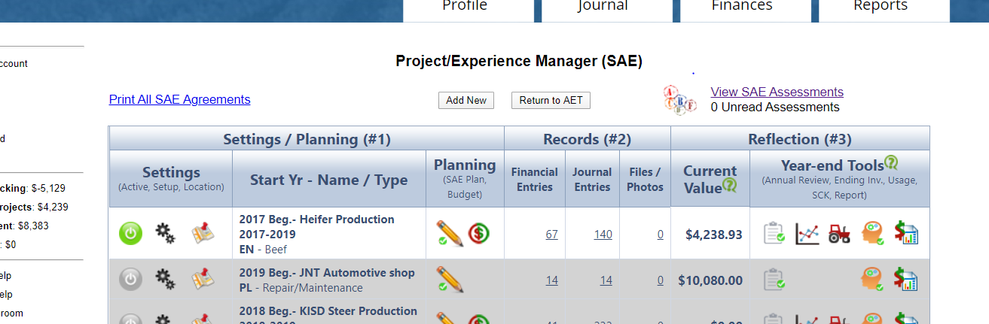

This will take you to the Experience – Yearly Inventory Valuation page, click on the plus sign next to the suggested value.
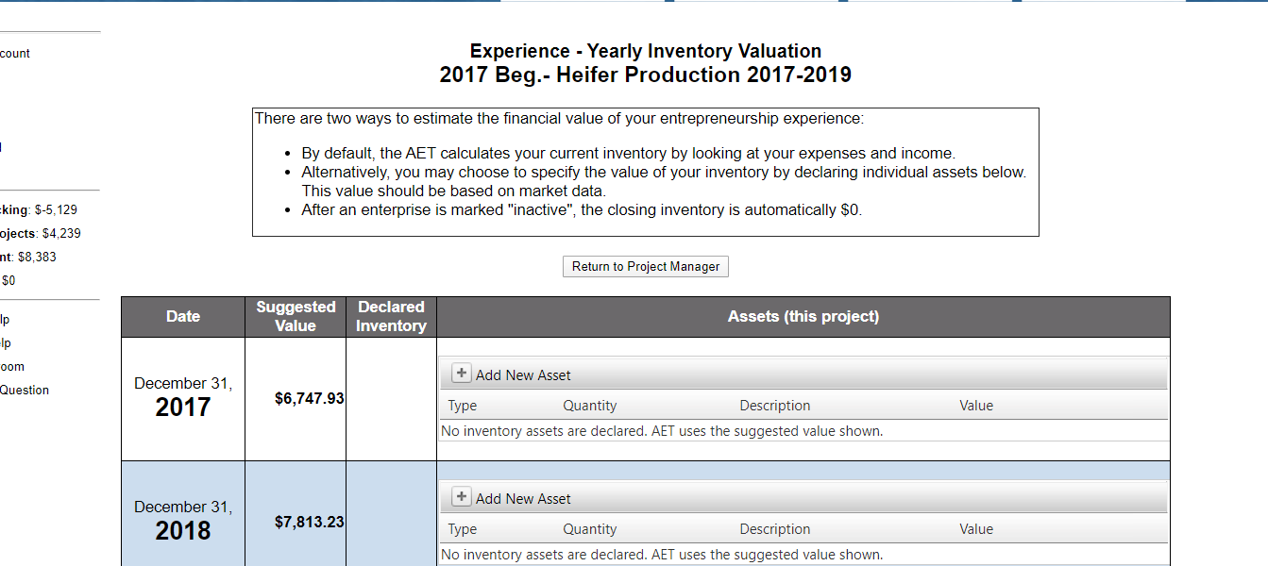

This will open up a pop up window where you can fill out the facts for this project. You want to make sure you put the appropriate type, quantity, description and value. The value was the number next to the plus sign you clicked on. Then click add item.

