AREA III BENEVOLENT FUND
NAME
SCHOOL
ADDRESS
CITY ZIP
BENEFICIARY
RELATIONSHIP
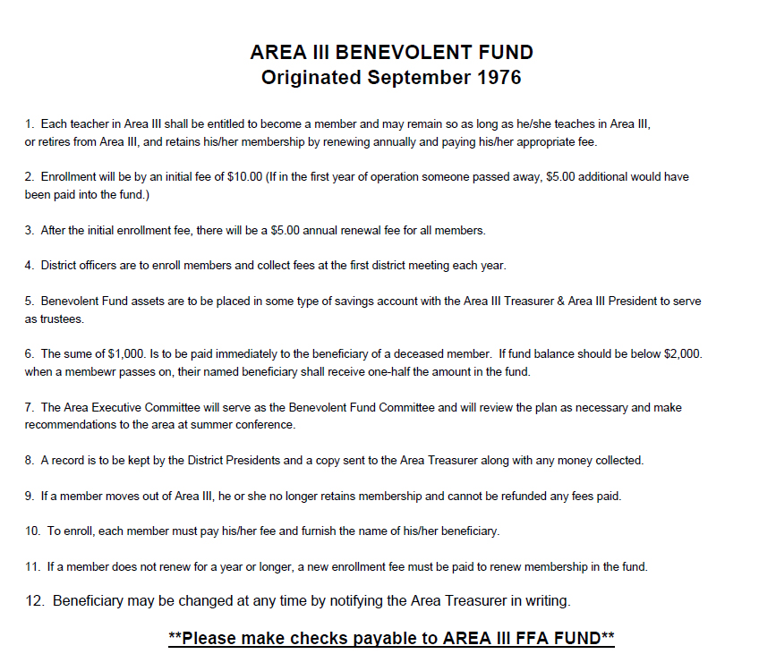
DISTRICT 1 2 3 4 5 6 7
NEW MEMBER= $10.00 RENEWAL= $ 5.00

